Sonali Matadin

Practical 1: Basic SQL Syntax

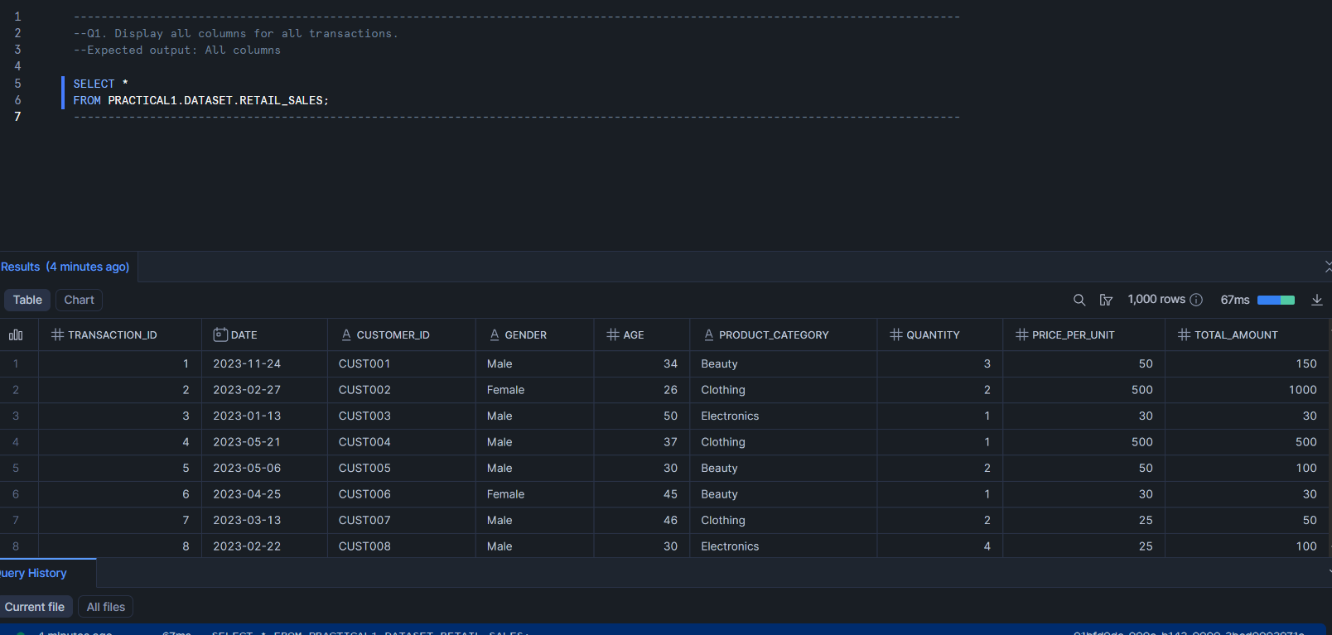Question 1:

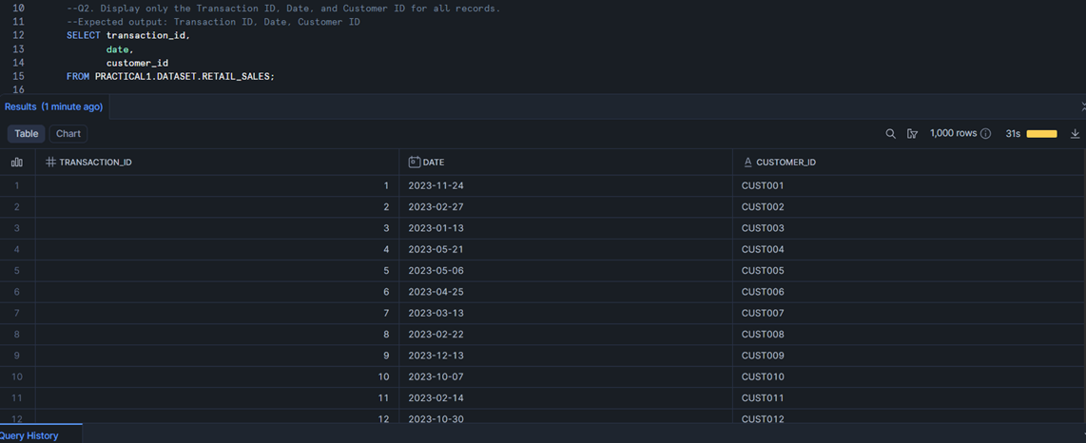Question 2:

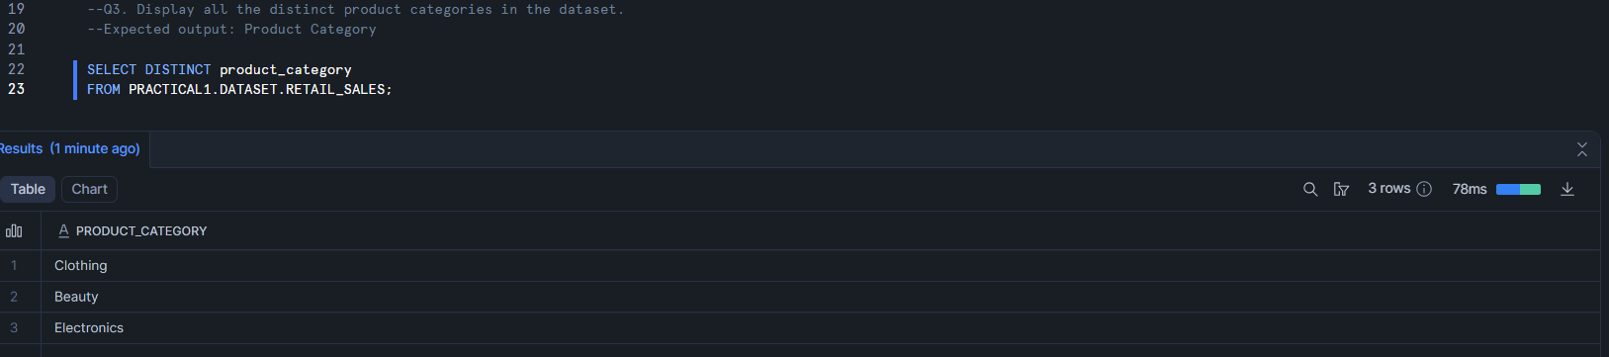Question 3:

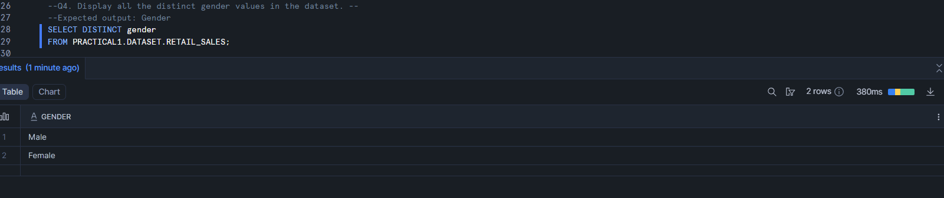Question 4:

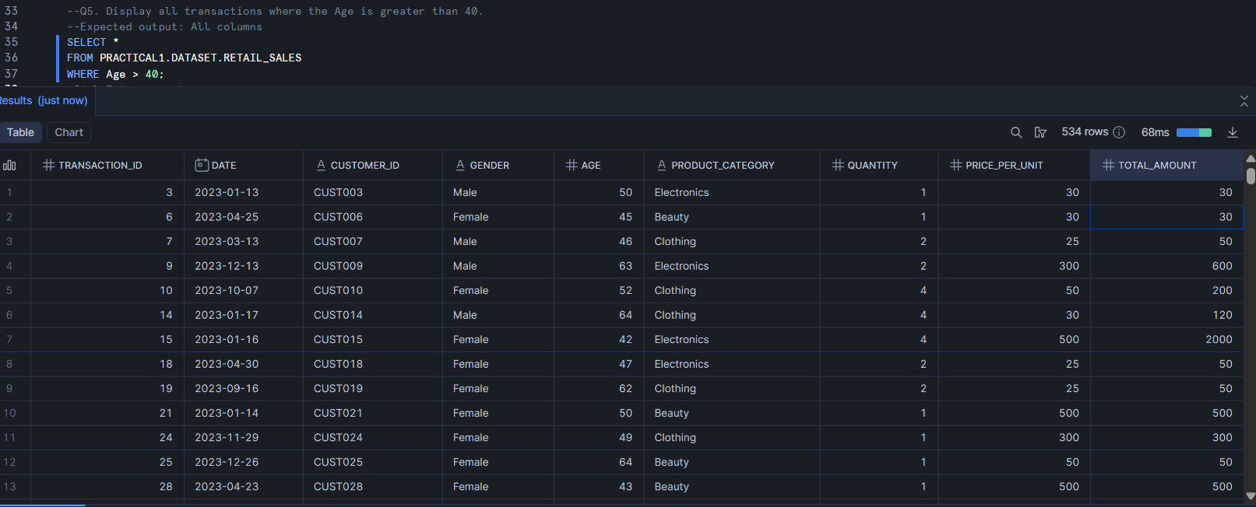Question 5:

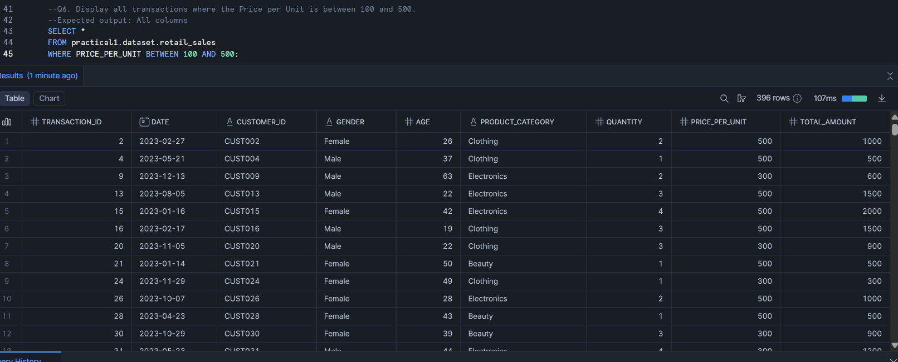Question 6:

Question 7:

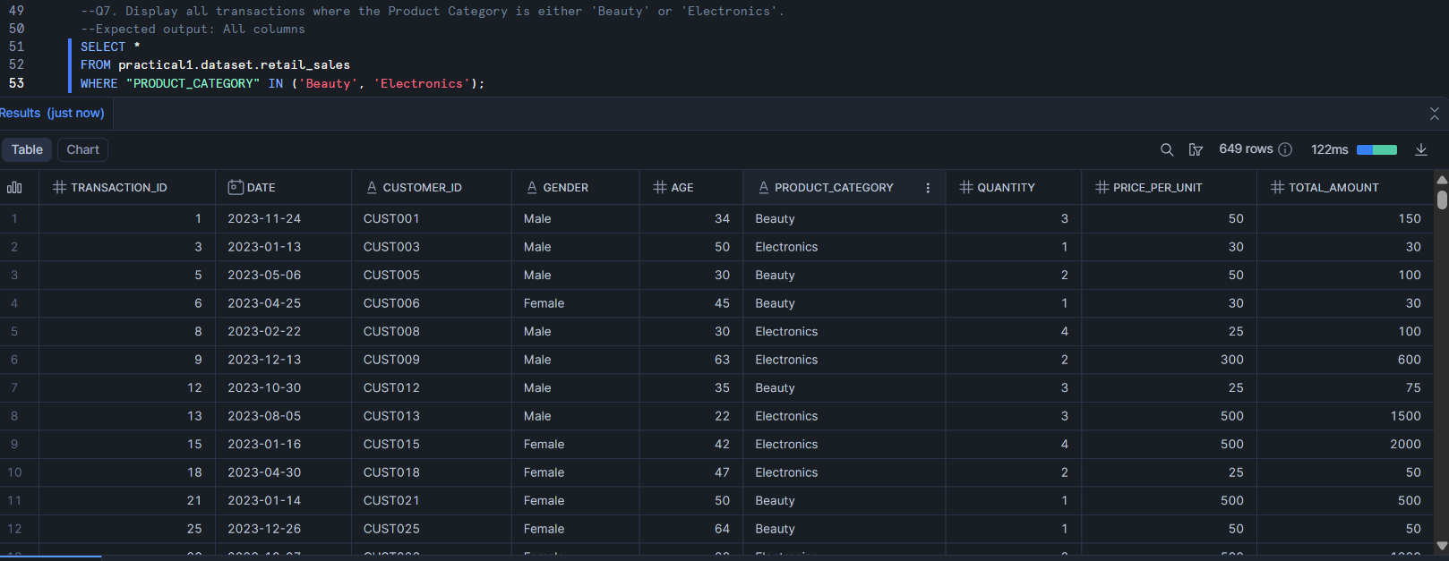

Question 8:

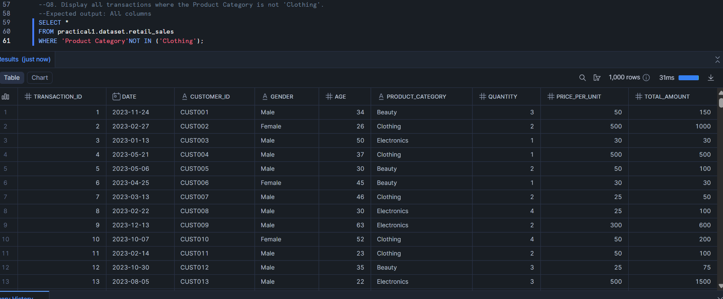

Question 9:

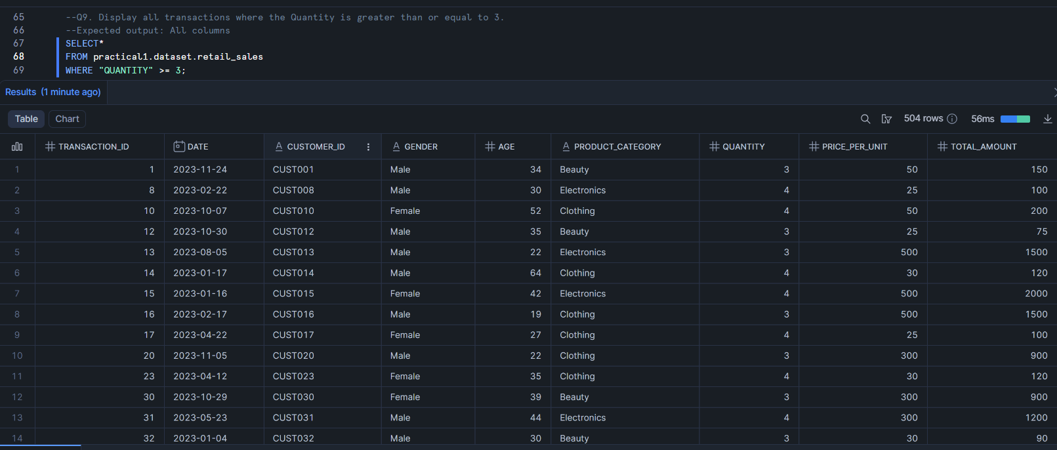

Question 10:

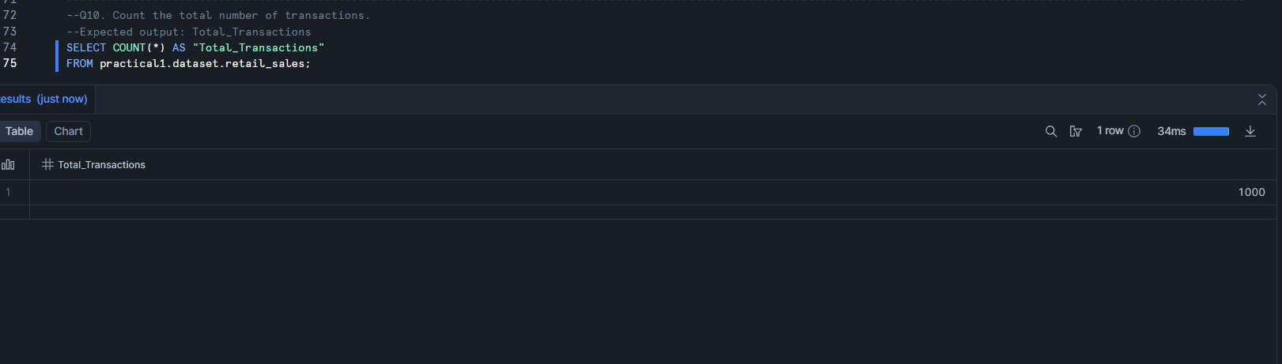

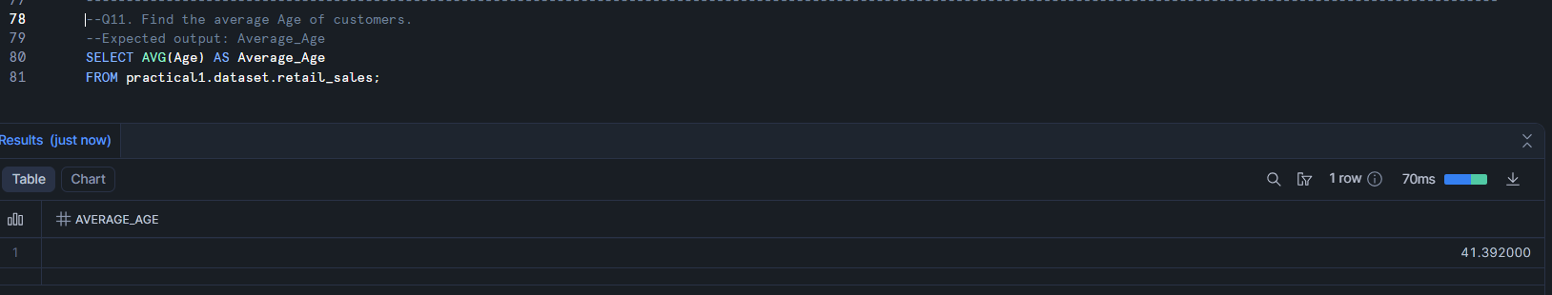Question 11:

Question 12:

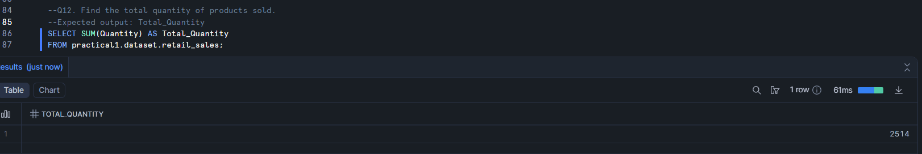

Question 13:

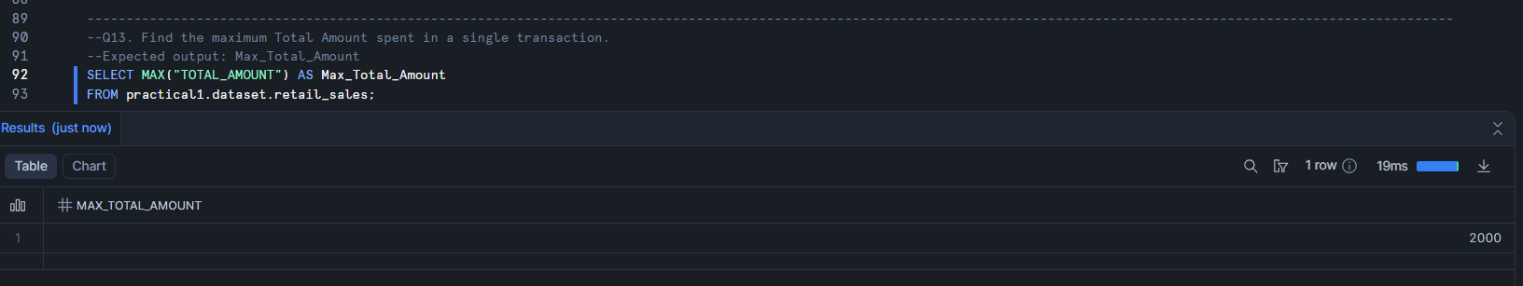

Question 14:

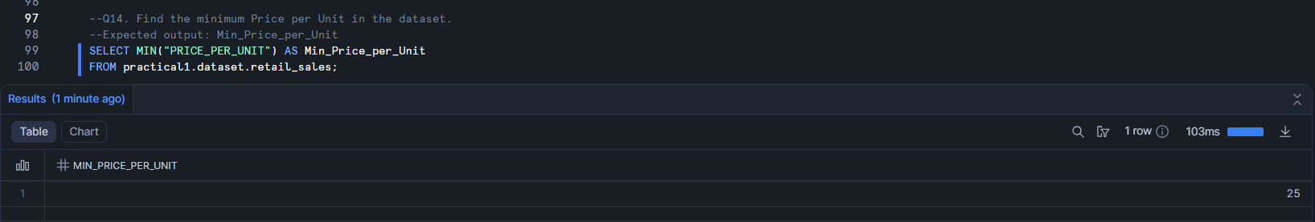

Question 15: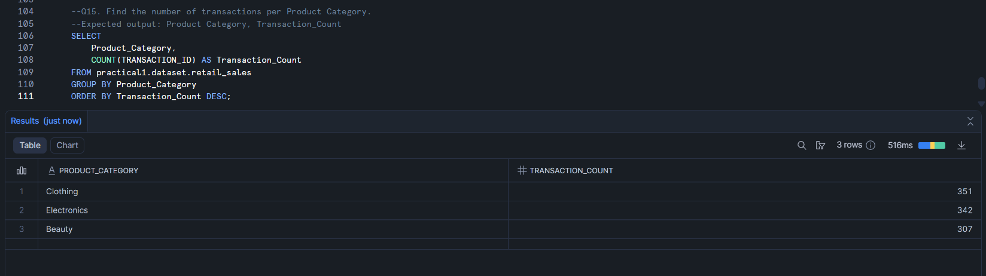

Question 16:

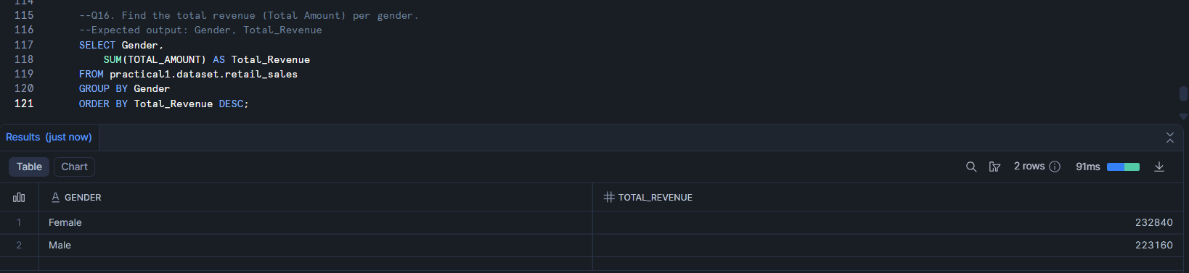

Question 17:

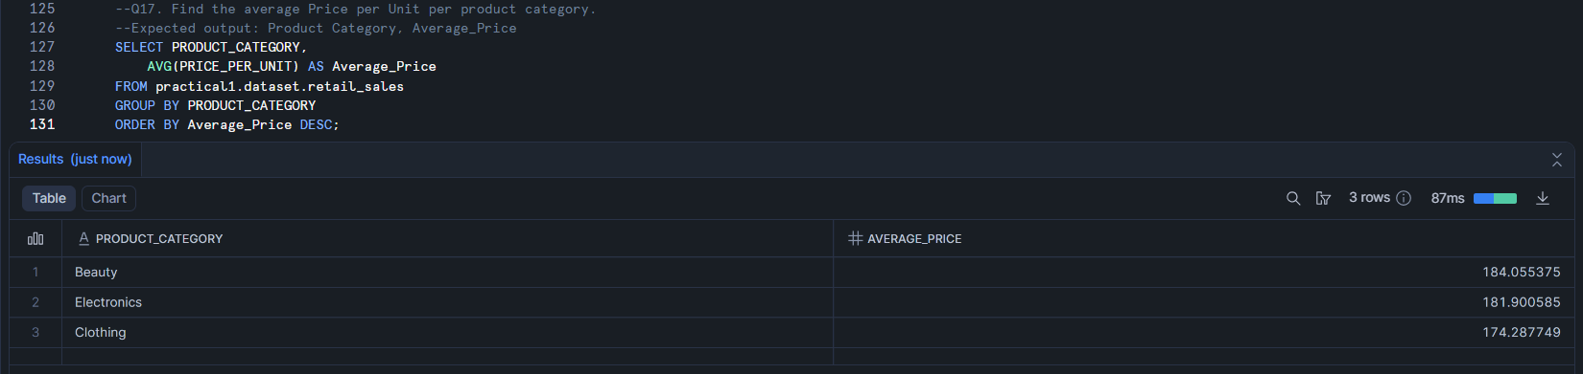

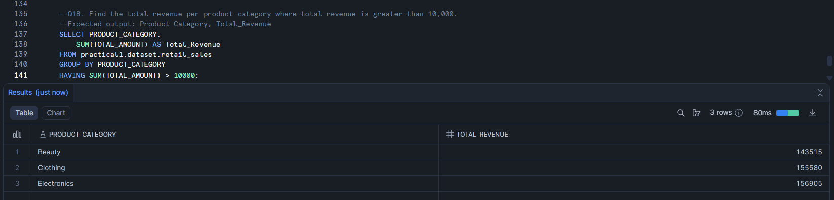Question 18:

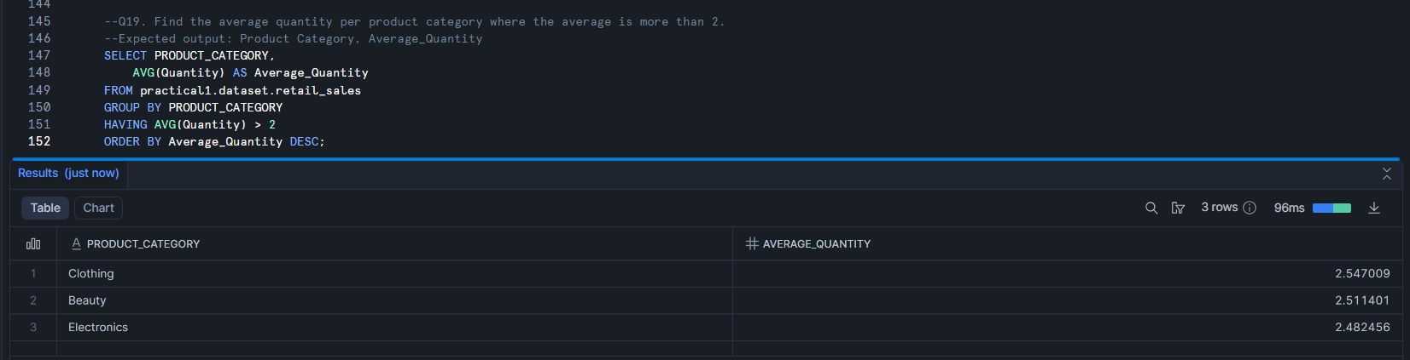Question 19:

Question 20:



Question 21:

